# Croup (Acute Laryngotracheobronchitis)

## *Executive summary*

## Introduction

## Croup is a common, primarily childhood, viral respiratory tract illness causing symptoms which may involve a harsh barking cough and (inspiratory) stridor. The vast majority of children with croup recover without consequences or sequelae; however, it can be life-threatening in young infants. Croup most often affects children aged 6 months to 3 years, with a peak incidence during the second year of life. However, children as young as 3 months of age, or adolescents and, very rarely, adults can be affected. The most common viral causes are parainfluenza viruses.

## Target users

* Doctors
* Nurses

## Target area of use

* Outpatient department
* Ward

## Key areas of focus / New additions / Changes

This guideline addresses the management of croup in children.

## Limitations

None

## Presenting symptoms and signs

Croup usually begins with nonspecific respiratory symptoms (ie, rhinorrhoea, sore throat, cough). Fever is generally low grade and is present in 50% of cases.

Within 1 to 2 days, the characteristic signs of hoarseness, barking cough, and inspiratory stridor develop; often suddenly.

* Stridor is often worse on exertion.
* Variable degree of respiratory distress.
* Symptoms generally worse at night.
* Symptoms can last for 2 weeks but typically resolve within 3-7 days.

## Westley croup score

Croup scores help clinicians in assessing the patient’s degree of respiratory compromise. The Westley score evaluates the severity of croup by assessing five factors: level of **consciousness**, **cyanosis**, **stridor**, **air entry**, and **retractions**. The point values given for each factor are listed below, and the final score sum has a range of 0 to 17.

|  |  |
| --- | --- |
| **Westley croup score** | |
| Stridor | None: 0 |
| With agitation: +1 |
| At rest: +2 |
| Chest wall retractions | None: 0 |
| Mild: +1 |
| Moderate: +2 |
| Severe: +3 |
| Cyanosis | None: 0 |
| With agitation: +4 |
| At rest: +5 |
| Level of consciousness | Normal: 0 |
| Disoriented: +5 |
| Air entry | Normal: 0 |
| Decrease: +1 |

**Score <2 – mild disease** (occasional barking cough, hoarseness, no stridor at rest, mild or absent suprasternal or subcostal retractions)

**Score 3-5: moderate disease** (findings include frequent cough, audible stridor at rest, and visible retractions, but little distress or agitation)

**Score 6-11: severe disease** (patients present with prominent inspiratory, and occasionally expiratory stridor, frequent cough, marked chest wall retractions, decreased air entry on auscultation, significant distress and agitation.

**A Westley score of ≥ 12 indicates impending respiratory failure**; at this point, a barking cough and inspiratory stridor may no longer be prominent – it presents with lethargy, cyanosis and decreasing retractions.

## Management

Taking a child with stridor outdoor into the cool air for 10 minutes can give him/her some relieve. Parent can be advised to do this. In addition, advise caregivers to have the child breathe warm moist air. This can be done by:

* running hot water in your shower with the bathroom door closed. After the bathroom becomes steamy, the parent can sit with the child in the room for about 10 minutes.
* Have the child breathe through a warm, wet washcloth lightly placed over the mouth and nose.

Treatment depends on the severity.

**Mild disease:**

* Give paracetamol (10-15 mg/kg TDS/QDS) or ibuprofen (5-10 mg/kg TDS) for fever
* Encourage adequate fluid intake
* Giving a single dose of oral dexamethasone 0.6mg/kg or prednisolone 1-2mg/kg may be of benefit.
* Send patient home
* Advised to return if symptoms worsen

**In moderate to severe croup**

* Admit to the ward
* Start oxygen therapy
* Give dexamethasone 0.6 mg/kg or prednisolone 1-2 mg/kg by mouth. Repeat dose after 12 hours if necessary
* Nebulised adrenaline (epinephrine) solution 1 in 1,000 (1 mg/mL) should be given with close clinical monitoring in a dose of 400 micrograms/kg (maximum 5 mg) repeated every 30 minutes if necessary.
* Monitor closely and send home when respiratory distress and stridor resolves.

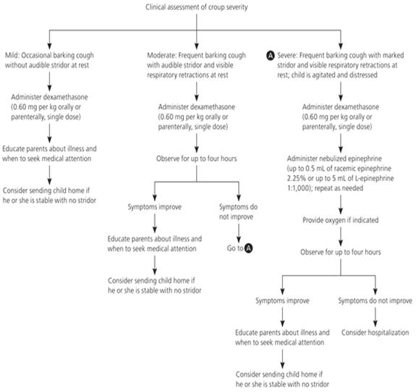

## References

Colledge, Nicki R., Brian R. Walker, Stuart Ralston, and Stanley Davidson. 2010. Davidson's principles and practice of medicine. Edinburgh: Churchill Livingstone/Elsevier.

Kliegman, Robert., et al. Nelson Textbook of Pediatrics. Edition 20. Phialdelphia, PA: Elsevier, 2016.

Management of acute respiratory diseases in the pediatric population. The role of oral corticosteroids. Italian Journal of Pediatrics 43(1). December 2017. Retrieved from https://www.researchgate.net/figure/Westley-croup-score_tbl7_315597265 on 25th February 2017.

Waseem M (2018). Otitis Media. Medscape. Retrieved from https://emedicine.medscape.com/article/994656-overview on 26th February, 2019

Standard Treatment Guidelines, 6th Edition, 2010. ISBN 978-9988-1-2538-7

Zoorob R et al (2011). Croup: An Overview. Retrieved from https://www.aafp.org/afp/2011/0501/p1067.html on 25th February, 2019.

|  |  |  |
| --- | --- | --- |
| **Written by:** | Name: Fatoumata Sawaneh | Date: 27 February 2019 |
| **Reviewed by:** | Name: Baderinwa Abatan | Date: 3 May 2019 |
| **Version:** | **Change history:** | **Review due date:** |
| 1.0 | New document | 31 May 2021 |
| Review Comments (*if applicable)* |  |  |